Author Guidelines for ‘Artigo de divulgação de cav’

Author(s) Name(s) and Numbers

Author Affiliation(s)
for example Instituto Superior Técnico
Av. Rovisco Pais, 1049-001 Lisboa, Portugal
E-mail: {john.smith, mary.delp}@x.x.x

Abstract
The abstract should appear at the top of the left-hand column of text, about 0.5 inch (12 mm) below the title area and no more than 3.125 inches (80 mm) in length. Leave a 0.5 inch (12 mm) space between the end of the abstract and the beginning of the main text. The abstract should contain about 100 to 150 words.
This template should be taken as the default template; most characteristics recommended here shall not be changed, e.g. font size, but it can be changed to improve the graphical looking of the paper, e.g. insertion of boxes, color, etc.

Index Terms— One, two, three, four, five

1. Introduction
The paper must have at most 8 pages formatted as described here. All manuscripts must be in Portuguese unless there is a non-Portuguese speaking student in the group; in that case, the manuscript will be in English.
These guidelines include complete descriptions of the fonts, spacing, and related information for producing your manuscripts.

2. FORMATTING YOUR PAPER
All printed material, including text, illustrations, and charts, must be kept within a print area of 7 inches (178 mm) wide by 9 inches (229 mm) high. Do not write or print anything outside the print area. The top margin must be 1 inch (25 mm), except for the title page, and the left margin must be 0.75 inch (19 mm). All text must be in a two-column format. Columns are to be 3.39 inches (86 mm) wide, with a 0.24 inch (6 mm) space between them. Text must be fully justified. Pages must be numbered.
Try to make the paper visually pleasant, this means for example that figures should be readable, and may use color.
Avoid long segments of plain text; try to structure the text in order it is more readable.

3. Page title section
The paper title (on the first page) should begin 1.38 inches (35 mm) from the top edge of the page, centered, completely capitalized, and in Times 14-point, boldface type. The authors’ name(s) and affiliation(s) appear below the title in capital and lower case letters. Papers with multiple authors and affiliations may require two or more lines for this information.

4. Type-style and fonts
To achieve the best rendering, we strongly encourage you to use Times-Roman font. In addition, this will give the set of papers a more uniform look. Use a font that is no smaller than nine point type and no bigger than ten point type throughout the paper, including figure captions.
In nine point type font, capital letters are 2 mm high. If you use the smallest point size, there should be no more than 3.2 lines/cm (8 lines/inch) vertically. This is a minimum spacing; 2.75 lines/cm (7 lines/inch) will make the paper much more readable. Larger type sizes require correspondingly larger vertical spacing. Please do not double-space your paper. True-Type 1 fonts are preferred.
The first paragraph in each section should not be indented, but all following paragraphs within the section should be indented as these paragraphs demonstrate.

5. MAjor headings
Major headings, for example, “1. Introduction”, should appear in all capital letters, bold face if possible, centered in the column, with one blank line before, and one blank line after. Use a period (“.”) after the heading number, not a colon. It is suggested all headings are numbered in an automatic way.

5.1. Subheadings
Subheadings should appear in lower case (initial word capitalized) in boldface. They should start at the left margin on a separate line.

5.1.1. Sub-subheadings
Sub-subheadings, as in this paragraph, are discouraged. However, if you must use them, they should appear in lower case (initial word capitalized) and start at the left margin on a separate line, with paragraph text beginning on the following line. They should be in italics.

6. Illustrations, graphs, photographs, AND LINKS
Illustrations must appear within the designated margins. They may span the two columns. If possible, position illustrations at the top of columns, rather than in the middle or at the bottom. Caption and number every illustration with font size 10. Each figure should be minimally described in the text and should not appear before it is mentioned in the text.
If you want to include material such as video, and audio do it by using a link included as reference.

7. Footnotes
Use footnotes sparingly (or not at all!) and place them at the bottom of the column on the page on which they are referenced. Use Times 9-point type, single-spaced. To help your readers, avoid using footnotes altogether and include necessary peripheral observations in the text (within parentheses, if you prefer, as in this sentence).

Acknowledgements
This section includes any acknowledgement you may wish to make.

References
List and number all bibliographical references at the end of the paper. The references can be numbered in alphabetic order or in order of appearance in the document.
All the references in the list MUST be referred in the text at some stage. When referring to them in the text, type the corresponding reference number in square brackets as shown at the end of this sentence [1]. It is suggested that all references are introduced as links to be list of references to allow automatic updating. The various elements in a reference must be ordered and formatted as in the examples in the following depending on their type, e.g. conference paper, journal paper, book.

- G. O. Young, “Synthetic structure of industrial plastics (Book style with paper title and editor),” in Plastics, 2nd ed. vol. 3, J. Peters, Ed. New York: McGraw-Hill, 1964, pp. 15–64.
- W.-K. Chen, Linear Networks and Systems (Book style). Belmont, CA: Wadsworth, 1993, pp. 123–135.
- H. Poor, An Introduction to Signal Detection and Estimation. New York: Springer-Verlag, 1985, ch. 4.
- B. Smith, “An approach to graphs of linear forms (Unpublished work style),” unpublished.
- E. H. Miller, “A note on reflector arrays (Periodical style—Accepted for publication),” IEEE Trans. Antennas Propagat., to be published.
- J. Wang, “Fundamentals of erbium-doped fiber amplifiers arrays (Periodical style—Submitted for publication),” IEEE J. Quantum Electron., submitted for publication.
- C. J. Kaufman, Rocky Mountain Research Lab., Boulder, CO, private communication, May 1995.
- Y. Yorozu, M. Hirano, K. Oka, and Y. Tagawa, “Electron spectroscopy studies on magneto-optical media and plastic substrate interfaces(Translation Journals style),” IEEE Transl. J. Magn.Jpn., vol. 2, Aug. 1987, pp. 740–741 [Dig. 9th Annu. Conf. Magnetics Japan, 1982, p. 301].
- M. Young, The Techincal Writers Handbook. Mill Valley, CA: University Science, 1989.
- J. U. Duncombe, “Infrared navigation—Part I: An assessment of feasibility (Periodical style),” IEEE Trans. Electron Devices, vol. ED-11, pp. 34–39, Jan. 1959.
- S. Chen, B. Mulgrew, and P. M. Grant, “A clustering technique for digital communications channel equalization using radial basis function networks,” IEEE Trans. Neural Networks, vol. 4, pp. 570–578, July 1993.
- R. W. Lucky, “Automatic equalization for digital communication,” Bell Syst. Tech. J., vol. 44, no. 4, pp. 547–588, Apr. 1965.
- S. P. Bingulac, “On the compatibility of adaptive controllers (Published Conference Proceedings style),” in Proc. 4th Annu. Allerton Conf. Circuits and Systems Theory, New York, 1994, pp. 8–16.
- G. R. Faulhaber, “Design of service systems with priority reservation,” in Conf. Rec. 1995 IEEE Int. Conf. Communications, pp. 3–8.
- W. D. Doyle, “Magnetization reversal in films with biaxial anisotropy,” in 1987 Proc. INTERMAG Conf., pp. 2.2-1–2.2-6.
- G. W. Juette and L. E. Zeffanella, “Radio noise currents n short sections on bundle conductors (Presented Conference Paper style),” presented at the IEEE Summer power Meeting, Dallas, TX, June 22–27, 1990, Paper 90 SM 690-0 PWRS.
- J. G. Kreifeldt, “An analysis of surface-detected EMG as an amplitude-modulated noise,” presented at the 1989 Int. Conf. Medicine and Biological Engineering, Chicago, IL.
- J. Williams, “Narrow-band analyzer (Thesis or Dissertation style),” Ph.D. dissertation, Dept. Elect. Eng., Harvard Univ., Cambridge, MA, 1993.
- N. Kawasaki, “Parametric study of thermal and chemical nonequilibrium nozzle flow,” M.S. thesis, Dept. Electron. Eng., Osaka Univ., Osaka, Japan, 1993.
- J. P. Wilkinson, “Nonlinear resonant circuit devices (Patent style),” U.S. Patent 3 624 12, July 16, 1990.
- IEEE Criteria for Class IE Electric Systems (Standards style), IEEE Standard 308, 1969.
- Letter Symbols for Quantities, ANSI Standard Y10.5-1968.
- R. E. Haskell and C. T. Case, “Transient signal propagation in lossless isotropic plasmas (Report style),” USAF Cambridge Res. Lab., Cambridge, MA Rep. ARCRL-66-234 (II), 1994, vol. 2.
- E. E. Reber, R. L. Michell, and C. J. Carter, “Oxygen absorption in the Earth’s atmosphere,” Aerospace Corp., Los Angeles, CA, Tech. Rep. TR-0200 (420-46)-3, Nov. 1988.
- (Handbook style) Transmission Systems for Communications, 3rd ed., Western Electric Co., Winston-Salem, NC, 1985, pp. 44–60.
- Motorola Semiconductor Data Manual, Motorola Semiconductor Products Inc., Phoenix, AZ, 1989.
- (Basic Book/Monograph Online Sources) J. K. Author. (year, month, day). Title (edition) [Type of medium]. Volume issue). Available: http://www.(URL)
- J. Jones. (1991, May 10). Networks (2nd ed.) [Online]. Available: http://www.atm.com
- (Journal Online Sources style) K. Author. (year, month). Title. Journal [Type of medium]. Volume(issue), paging if given. Available: http://www.(URL)
- R. J. Vidmar. (1992, August). On the use of atmospheric plasmas as electromagnetic reflectors. IEEE Trans. Plasma Sci. [Online]. 21(3). pp. 876—880. Available: http://www.halcyon.com/pub/journals/21ps03-vidmar

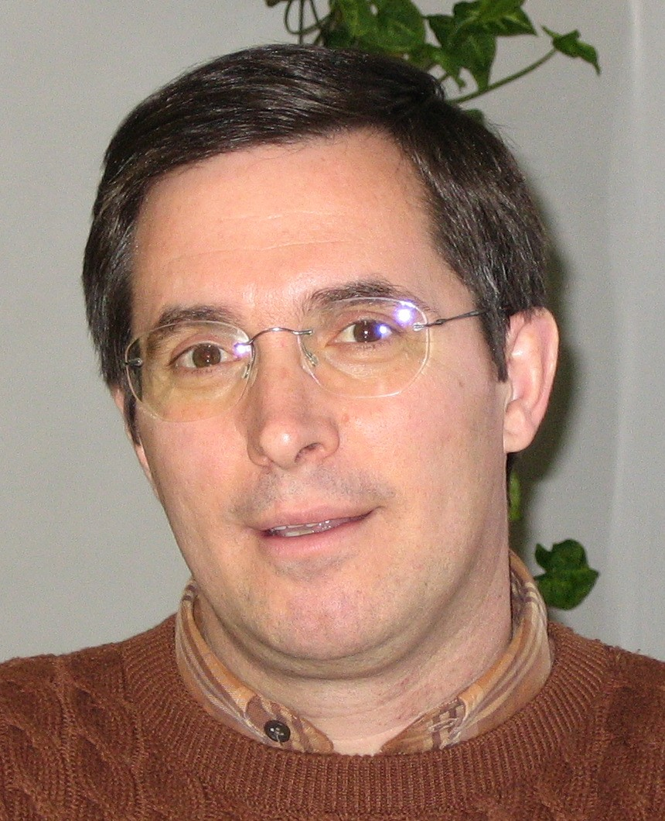
First A. Author and the other authors may include biographies at the end of regular papers. The first paragraph may contain a place and/or date of birth (list place, then date). Next, the author’s educational background is listed. The degrees should be listed with type of degree in what field, which institution, city, state or country, and year degree was earned. The author’s major field of study should be lower-cased.
The second paragraph uses the pronoun of the person (he or she) and not the author’s last name. It lists military and work experience, including summer and fellowship jobs. Job titles are capitalized. The current job must have a location; previous positions may be listed without one. Information concerning previous publications may be included. Try not to list more than three books or published articles. The format for listing publishers of a book within the biography is: title of book (city, state: publisher name, year) similar to a reference. Current and previous research interests ends the paragraph.
The third paragraph begins with the author’s title and last name (e.g., Dr. Smith, Prof. Jones, Mr. Kajor, Ms. Hunter). List any memberships in professional societies other than the IEEE. Finally, list any awards and work for IEEE committees and publications. If a photograph is provided, the biography will be indented around it. The photograph is placed at the top left of the biography. Personal hobbies will be deleted from the biography.

